Student Recycling Script
Adapted from P.S. 16 Staten Island
Hello everyone, my name is ______________________ and I am in class _______________.
I am on the Recycling Team here at ________________________!
This school is a “Green” School. Does anyone know what that means?
Well, it means that we try to recycle as much as we can. We try to take care of the environment. We use “green” products to clean up our school.
Today you are getting this bin to put all of your paper recycling in. Every classroom must recycle paper. Does anyone know what paper items can be recycled? (Answers can be: tissue boxes, construction paper, tubes from paper towel rolls, magazines, cardboard boxes from snacks, paper bags, and loose-leaf paper.)
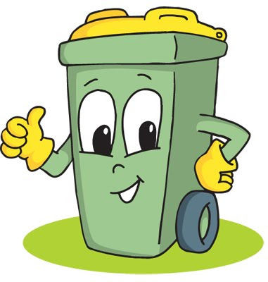
YOU CANNOT PUT TISSUE PAPER, TISSUES, PENCIL SHAVINGS, CRAYONS, FOOD, OR GLUE IN THE PAPER RECYCLING BINS!
Lastly, at lunchtime, everyone must pour out and empty out their milk containers and place the containers into the proper bottle recycling bin. Thank you for your time and keep recycling!

