Here’s the rubric that Green Team students at P.S. 154 Queens created to determine grades for their classroom and office recycling inspections. Involve your Green Team in determining the criteria for each rating or grade level.
Once you have a grading criteria, print and laminate enough copies of page two of this document for every classroom and office in your school. Hang the sign by every classroom and office door, and use dry era markers to record grades for each room. Establish a schedule for routinely evaluating the rooms.
“A” – On Target
Recycling: All bins must be correctly labeled - garbage in the black or grey bin, paper in the green bin, and metal, plastic, cartons, glass in the blue bin.
Energy: Turn off lights when not in the classroom, all appliances not being used (smartboards, projectors, and computers) must be turned off. Cell phone chargers, pencil sharpeners, etc. must be unplugged when not in use. Do not have excessive appliances – coffee makers, microwave, etc. in the classroom.
Plants: While not mandatory, they help create a green environment. Any classroom plants will contribute to bonus points for the class.
“B” – Developing
Recycling: Two-thirds of the above recycling criteria must be met.
Energy: Lights must be off when classroom is empty; some appliances may be plugged in despite not being in use.
“C” – Needs Improvement
Two bins are properly sorted/used and all electricity fails to meet “A” standards.
OR
One recycling bin is correctly sorted and all electrical items meet “A” standards.
Adapted from Sustainability Coordinator, Deise Kenny, P.S. 154Q
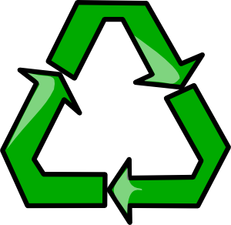
GREEN TEAM INSPECTION GRADE

GRADE

CLASS:
INSPECTION DATE:
GREEN TEAM MEMBER INITIALS:
COMMENTS:

